Image-Based 3D Reconstruction of Traditional Thai Pottery

1st Sai Aike Shwe Tun Aung
Vincent Mary School of Science, Engineering and Technology
Suvarnabhumi Campus, Assumption University of Thailand
Samut Prakan, Thailand
u6712122@au.edu

2nd Ekaterina Kazakova
Vincent Mary School of Science, Engineering and Technology
Suvarnabhumi Campus, Assumption University of Thailand
Samut Prakan, Thailand
u672006@au.edu

3rd Kyaw Thi Ha
Vincent Mary School of Science, Engineering and Technology
Suvarnabhumi Campus, Assumption University of Thailand
Samut Prakan, Thailand
u6715088@au.edu

Abstract—This project investigates image-based 3D reconstruction of pottery associated with Thai material culture for an interactive AR or VR exhibition. During the current reporting period, both selected pots arrived and were recorded using turn-around videos against a blue background. One pot arrived with a damaged lid and stand, so only its intact parts were recorded while the team attempted to repair the broken components. Frames were extracted using the previously developed Python tool. Several sampling intervals were tested through trial and error, including every frame, every second, third, and fifth frame. Selecting every third frame provided the best balance between image overlap and viewpoint movement. The team is currently developing a background removal algorithm before proceeding to reconstruction with COLMAP.
Keywords—Thai arts and culture, image-based rendering, photogrammetry, 3D reconstruction, earthenware, COLMAP

Introduction
Image-based reconstruction is a computer vision technique that creates a digital representation of a real object from photographs taken at different angles. It is used in areas like cultural preservation, education, entertainment, augmented reality and virtual reality. Instead of manually building every part of an object, the system estimates its shape and surface appearance from visible information in the images.
This project focuses on reconstructing traditional Thai pottery and water containers. These clay or ceramic containers have been used to store drinking water and water for household activities. Their shapes, materials, surface patterns and production methods can reflect local knowledge and traditional ways of living.
Several Thai cultural objects and themes were considered before this topic was selected. Large buildings and architectural structures were avoided because they require many photographs, outdoor access, and camera positions that may be difficult to reach and record. Small or medium pottery is more affordable, easier to control, and suitable for a project of this scale.
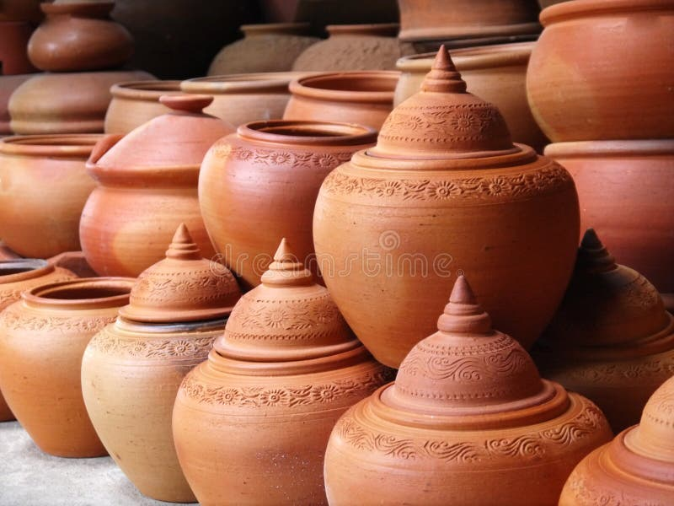
Fig. 1. Example image of traditional Thai pottery. Sourced from dreamstime.com

The topic was partly inspired by two team members from Myanmar who are familiar with similar clay water containers. This shared regional familiarity encouraged the team to study pottery used in Thailand while carefully distinguishing local traditions from visually similar Chinese, Indian, and other regional forms. The project recognizes that Thai material culture has also developed through long-term cultural exchange. Therefore, the selected objects may represent both locally rooted Thai pottery and forms that originated through Thai-Chinese adaptation. The main goal is to produce textured 3D models of at least two pottery objects associated with Thai cultural life and present them in an AR or VR environment where users can rotate, scale, and inspect them.

Literature Review
Image-based 3D reconstruction estimates the shape of an object from multiple two dimensional images. Szeliski [1] explains that images captured from different viewpoints can provide information about camera movement, depth and three dimensional structure. The quality of the result depends on factors like image overlap, surface detail, lighting consistency, and camera movement.
Structure from Motion is normally used during the first stage of reconstruction. It detects local features in each photograph and matches the same features across different images. These matches are used to estimate the camera positions and create a sparse set of 3D points. Bundle adjustment then improves the estimated camera parameters and point positions by reducing reprojection error.
Schönberger and Frahm [2] introduced an incremental Structure from Motion approach that was later released as part of COLMAP. COLMAP is now an open source system on GitHub that supports automatic reconstruction, command line processing, graphical visualization, and Python integration. It can produce camera poses, sparse point clouds, dense point clouds, surface meshes, and texture maps.
Multi View Stereo is used after the sparse reconstruction. It estimates depth information for many pixels and combines this information into a dense point cloud. Schönberger and colleagues [3] proposed a pixelwise view selection method that improves depth estimation by selecting appropriate source images. The dense point cloud can then be converted into a triangle mesh.
Meshroom is another open source reconstruction tool based on AliceVision [4]. Its visual workflow is convenient because the major processing stages are displayed as connected nodes. However, COLMAP was selected as the main tool for this project because it offers a simple automatic mode and detailed control when individual steps need to be adjusted. Blender will be used for model cleanup, while Unity or another platform provided by the course professor will be used for the final AR or VR presentation.

Methodology

​​Overall Project Design
The project follows an experimental image-based reconstruction process. At least two real pottery objects associated with Thai material culture will be photographed or recorded from multiple viewpoints after delivery. The selected objects intentionally differ in material appearance and decoration: one has a matte, unpainted clay surface with carved details, while the other has a glossy glaze and dragon motif. Images selected from the captures will be processed to estimate camera positions, reconstruct object surfaces, generate textures, and create models suitable for real-time visualization.
The work is divided into five general phases. The first phase covers cultural research, candidate screening, and object procurement. This phase has progressed to the ordering of two selected pots. The second phase will focus on delivery inspection, measurement, pilot image capture, and testing. The third phase will cover complete reconstruction using COLMAP. The fourth phase will involve mesh cleanup and optimization. The final phase will place the models inside an AR or VR environment.
The workflow is still intentionally flexible. Photograph counts, software settings, meshing methods, export formats, and presentation tools are current plans instead of fixed requirements, and might be adjusted as we go. The team will record changes, settings, and results from each attempt so that later decisions are based on measured reconstruction performance.

Object Research and Selection
During the current reporting period, the team conducted a broad online survey of Thai clay and ceramic water containers instead of purchasing the first available item. Many candidates were screened by comparing product names, descriptions, visual characteristics, and claimed origins with independent cultural and historical sources. Listings with unsupported claims of Thai origin or clearly unrelated imported decoration were removed. Chinese- and Indian-influenced candidates were not rejected solely because of cultural influence. Instead, the team examined whether those forms had been adapted, produced, used, or culturally recognized within Thailand.
The team also reviewed the historical development and functional categories of pottery in Thailand. Thai cultural sources distinguish earthenware from later high-fired stoneware and categorise household forms such as pots, jars, and water vessels [5], [6]. The review also showed that pottery in Thailand developed through cultural exchange. Chinese techniques and motifs were adapted within Thai production and household life over time. The Ratchaburi dragon-jar tradition is a relevant example because it developed through Chinese immigrant craftsmanship, local materials and production, and adaptation to Thai household use [7], [8]. This review helped the team evaluate candidates as cultural objects rather than treating every terracotta-colored product as Thai pottery.
For each object that passed the screening, the team began recording its likely Thai name, region, associated tradition, historical or household use, and supporting cultural source. These details remain under verification and will be updated as stronger sources are found. Marketplace labels alone are not being accepted as cultural evidence.
Candidate selection combined cultural verification with photogrammetric suitability. Each shortlisted object was evaluated using the following criteria.
1) The object should have a clear connection to Thai culture or traditional household life
2) The object should be rigid and should not change shape while being photographed
3) The object should be accessible from most viewing directions
4) The surface should contain visible texture, carving, color variation, or decorative patterns
5) Surface reflectivity and transparency should be identified and evaluated as potential reconstruction challenges
6) The object should be affordable, borrowable, or already available to a team member
7) The object should be safe to handle and should not be an important religious or historical artifact
Based on this screening, the project scope was expanded from one primary object to at least two pottery objects. Two contrasting candidates have now been ordered. The first is an unpainted red earthenware pot with a matte surface and carved ornamentation. The second is a glossy brown dragon-motif jar associated with a Thai-Chinese ceramic tradition. Using two objects will allow the team to compare how differences in reflectivity, color, ornamentation, texture, and symmetry affect feature matching and reconstruction quality.
Figure 1 shows one selected candidate. Its unpainted matte surface, carved decorative bands, rigid lid, and opaque clay body are favorable for image matching. At the same time, the rounded, rotationally symmetric body may produce ambiguous matches, while the lid, opening, pedestal, and lower surfaces will require higher and lower camera viewpoints. After delivery, the height, maximum diameter, opening diameter, and base diameter of both pots will be measured for scale correction and accuracy evaluation.
Figure 2 shows the second candidate, which is marketed as a 7-inch dragon jar. The team discussed its Chinese-influenced design with the course professor and received approval to include it as a Thai-Chinese cultural object. Dragon jars became established within Thai household life and are particularly associated with the ceramic tradition of Ratchaburi [7], [8]. The glossy glaze may create moving highlights that interfere with feature matching, while the raised dragon motif and color variation may provide additional visual features. The exact workshop and production location of the purchased object remain under verification.

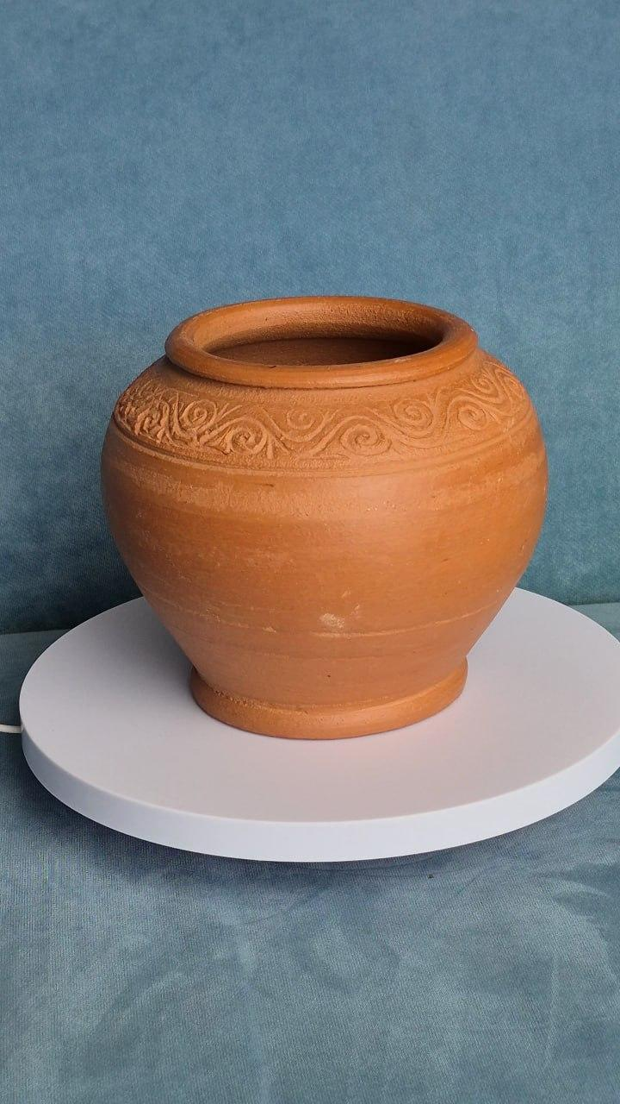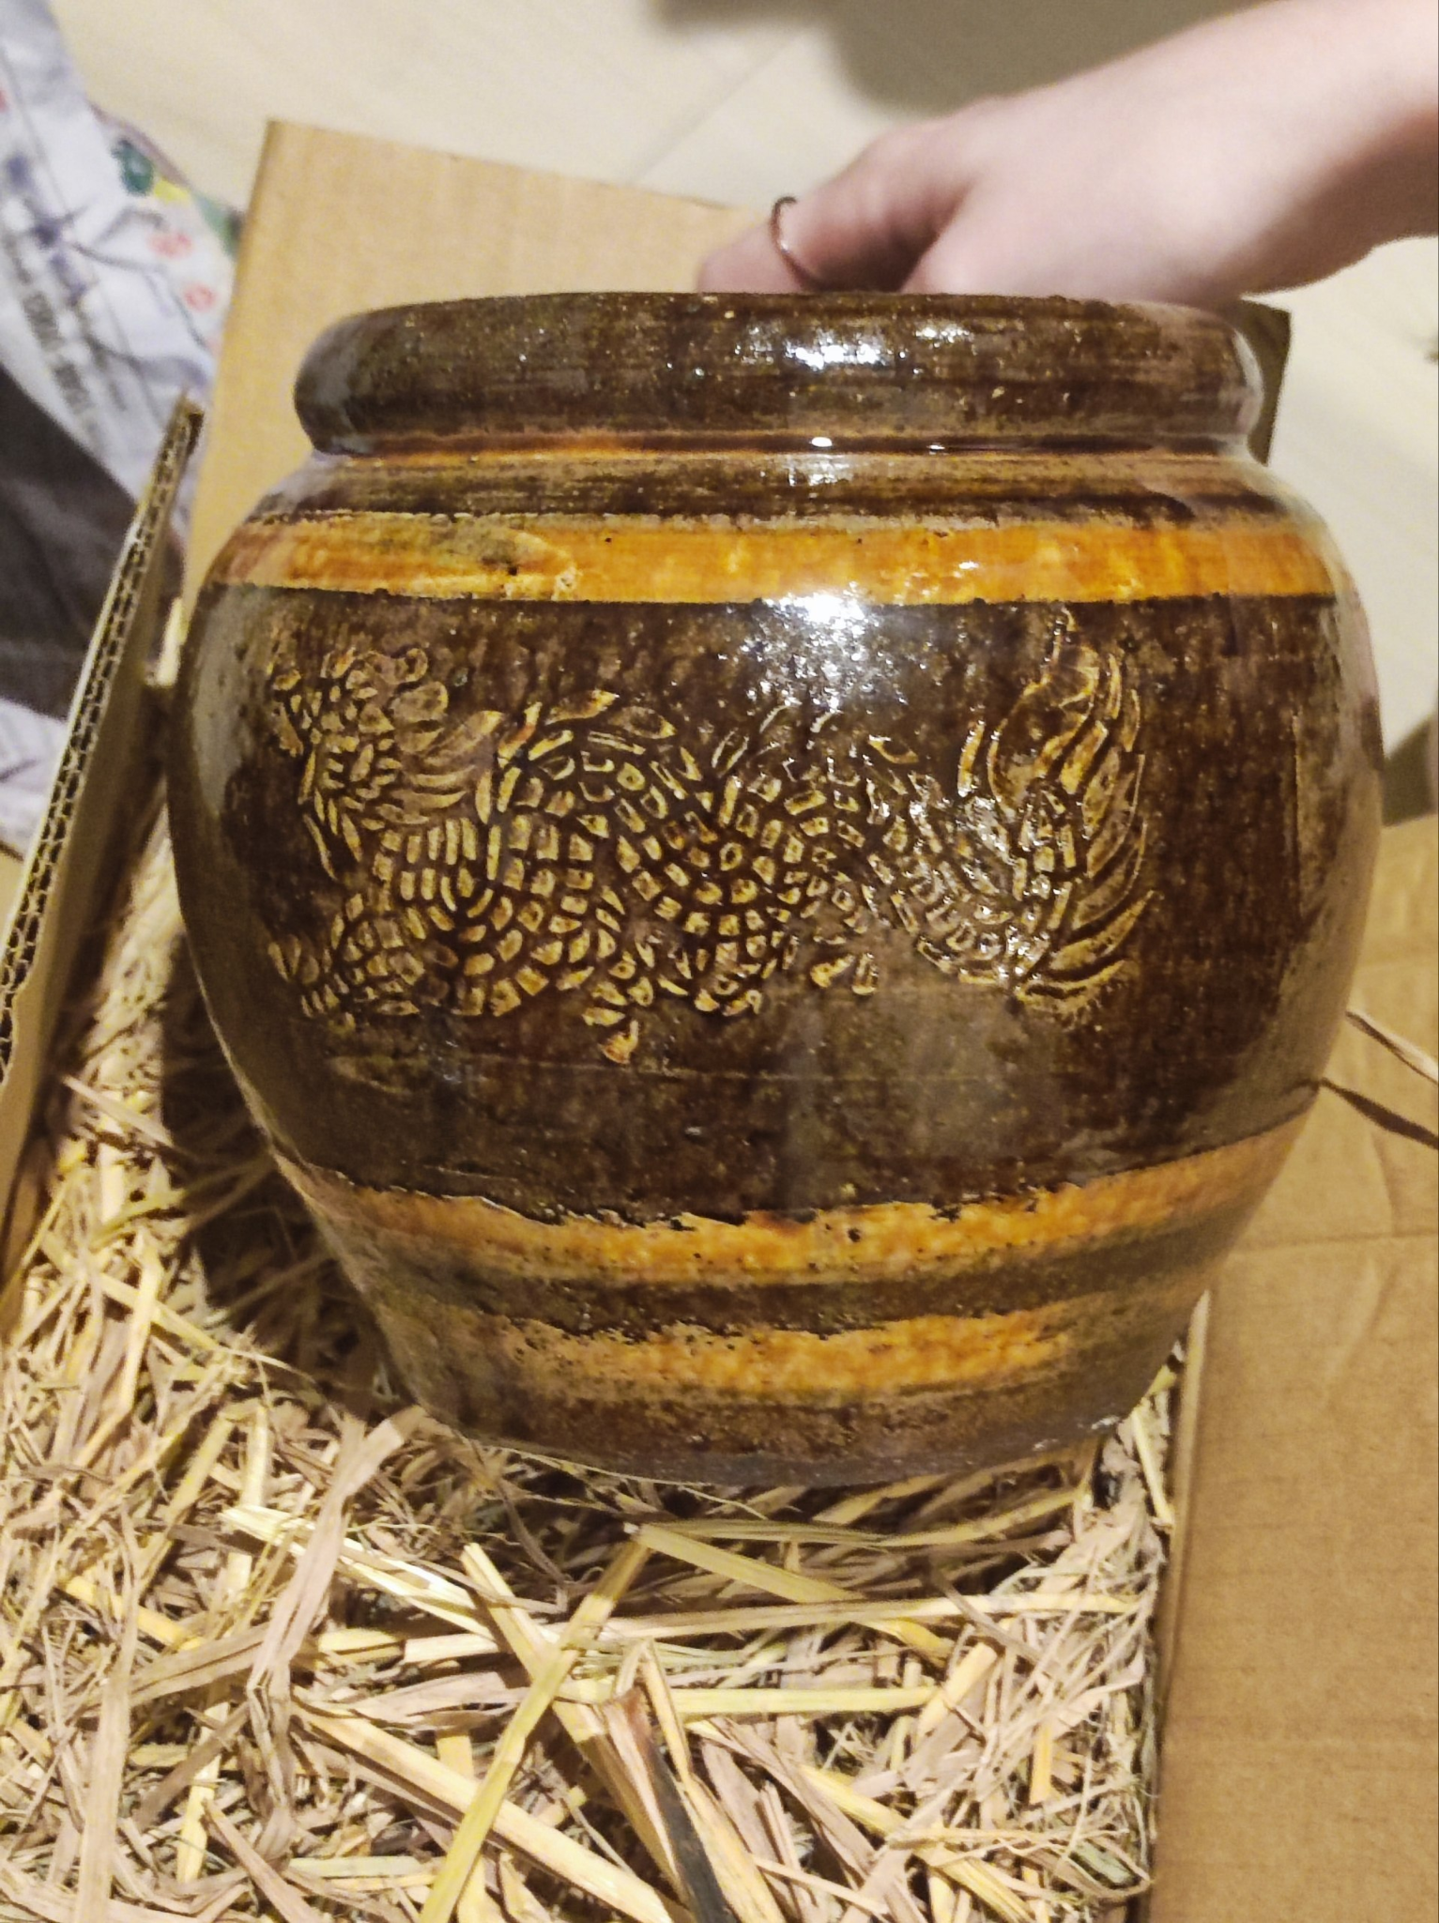
Fig. 2. Fig. 3.
Fig. 2. An unpainted red earthenware pot with carved decorative bands. The lid and base are broken, so were not photographed yet..

Fig. 3. A 7-inch dragon jar (โอ่งมังกร 7 นิ้ว), with a glossy brown glaze and raised dragon motif. The exact production location remains under verification.

Equipment and Capture Area
The main equipment will include a smartphone or digital camera, a tripod or camera support, two light sources, white fabric or tracing material for light diffusion, a measuring tape, and several printed reference markers. Most of this equipment can be borrowed from friends or created from inexpensive materials.
The capture area will be set up indoors to prevent changes in sunlight, wind, and background movement. The object will be placed on a stable stool or table. The team will leave enough space around the object for the camera operator to move safely.
The lighting will be placed on opposite sides of the object and covered with diffusing material. This should reduce hard shadows and strong reflections. The position and brightness of the lights will remain unchanged throughout one capture session. Direct flash will not be used.
A lightly textured background will be used instead of a completely plain wall. The background should provide enough features for camera pose estimation without attracting too much attention from the object. Printed markers may be placed on the table and around the capture area. These markers will not be attached directly to the pot.

Camera Preparation
After delivery, each pot will be inspected for damage, loose parts, glare, and areas that may be hidden during capture. The same camera and lens will be used throughout each dataset. Digital zoom, portrait effects, beauty filters, and automatic background blur will be disabled. Focus, exposure, and white balance will be locked when the camera application permits, and test photographs will confirm sharpness and highlight retention before the capture area is disturbed.

Image Acquisition and Dataset Preparation
The team has implemented a Python program that extracts individual frames from a 60 FPS video and saves them as separate image files. This creates a controllable image source for the photogrammetry pipeline and provides a repeatable alternative to manually capturing every photograph. However, every extracted frame will not automatically be sent to feature extraction or reconstruction. Adjacent frames in a 60 FPS video can be nearly identical, producing unnecessary computation and many redundant feature matches without adding a useful change in viewpoint. The pilot reconstruction will initially use approximately 30 to 40 selected images per object, while a complete dataset may contain approximately 80 to 150 selected images depending on the pilot results.
The preprocessing program will therefore be extended or configured to select frames at an adjustable interval, such as every second, third, or a larger number of frames, depending on the speed of camera or object rotation. Frame selection will aim to preserve substantial overlap while ensuring enough viewpoint change for camera-pose estimation. Blurred, obstructed, poorly exposed, and near-duplicate frames will also be removed. The interval is a starting plan rather than a fixed rule and will be changed after pilot reconstruction results are examined.
Python will be used to prepare the dataset required by COLMAP. The planned preprocessing outputs include a selected image sequence with consistent file names, a contact sheet for rapid visual review, and a separate object mask corresponding to each selected frame when masking is needed. Only the selected frames and their matching masks will be provided to COLMAP for feature extraction, feature matching, camera-pose estimation, and reconstruction. The team will compare more-dense and less-dense frame selections to identify an efficient balance between image overlap, viewpoint change, processing time, registration success, and reconstruction completeness.

Sparse and Dense Reconstruction
COLMAP automatic reconstruction will be used for the first test. If the dataset registers successfully, a controlled workflow will extract features, perform exhaustive matching and geometric verification, estimate camera poses with the incremental mapper, and refine the sparse model through bundle adjustment. Registered images, sparse points, and mean reprojection error will be recorded before PatchMatch Stereo and stereo fusion are used to create a dense colored point cloud. Meshroom remains a planned backup if COLMAP does not produce a usable result.

Mesh Generation and Texturing
Poisson and Delaunay-based surface reconstruction are planned for comparison. The meshes will be evaluated for overall completeness, false geometry, preservation of the rim and opening, and reconstruction of the pedestal and base. The selected mesh will be simplified and textured from the photographs, then checked for visible seams, blur, incorrect projections, and brightness changes.

Model Cleanup and Interactive Presentation
The textured models will be imported into Blender to remove unwanted background geometry, floating components, and simple holes. Each model will be oriented upright, scaled using physical measurements, and prepared in both high-detail and reduced-detail versions. OBJ or FBX will be tested first, although the final export format will follow the professor's exhibition requirements. Unity and AR Foundation remain the current plan for testing model placement, rotation, movement, and scaling if the course does not provide another platform.

Evaluation and Expected Challenges
Evaluation will combine technical measurements and visual inspection. The team plans to compare image-registration ratio, sparse and dense point counts, mean reprojection error, dimensional error, mesh completeness, texture quality, and optimized-model performance. The two selected objects introduce different expected challenges. The unpainted pot may be affected by rotational symmetry and repeated circular geometry, while the glazed dragon jar may produce viewpoint-dependent highlights and reflections. The raised dragon decoration may provide additional local features, but repeated sections of the motif may also create ambiguous matches. Video-frame sampling density will be evaluated as another experimental variable because frames that are too similar waste processing time, while frames that are too far apart may reduce matching reliability

Current Progress and Preliminary Analysis
Last week we moved from preparation into physical data collection and preprocessing. Both selected pottery objects have now arrived and were inspected before recording. One object arrived in usable condition, while the second object had damage to its lid and base. The decorative base was shattered into pieces. Because the base is one of the more visually distinctive parts of the object, the team attempted to glue the broken pieces together so that it may eventually be included in the reconstruction. The repair was not sufficiently stable for now, so only the intact components were recorded. The second pot was therefore captured without its damaged lid and stand.
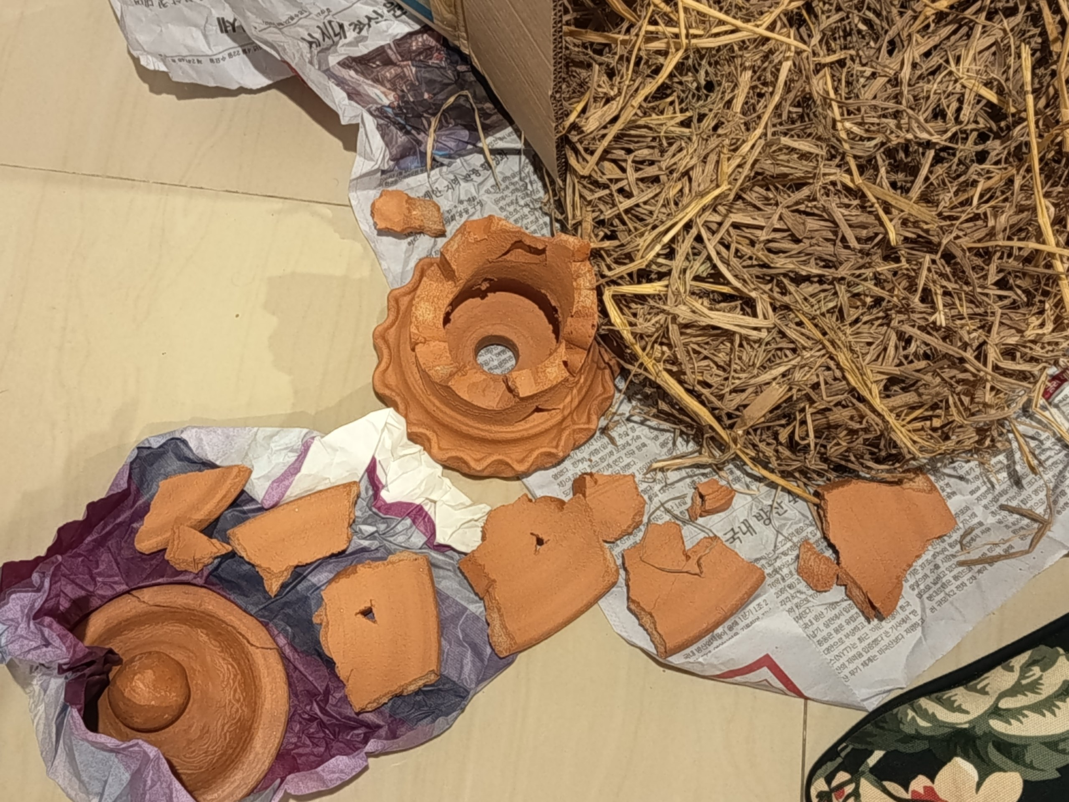
Fig. 4. The state in which the lid and stand arrived.
Turn-around videos were recorded at 60 FPS (frames per second) for both pottery objects using a blue background. The blue background was selected to provide clear visual separation between the pottery and the surrounding capture area and to support later background removal. Frames were then extracted from the videos using the Python frame clipping and combining workflow developed during the previous reporting period. This allowed the team to move directly from video capture to repeatable image dataset generation.
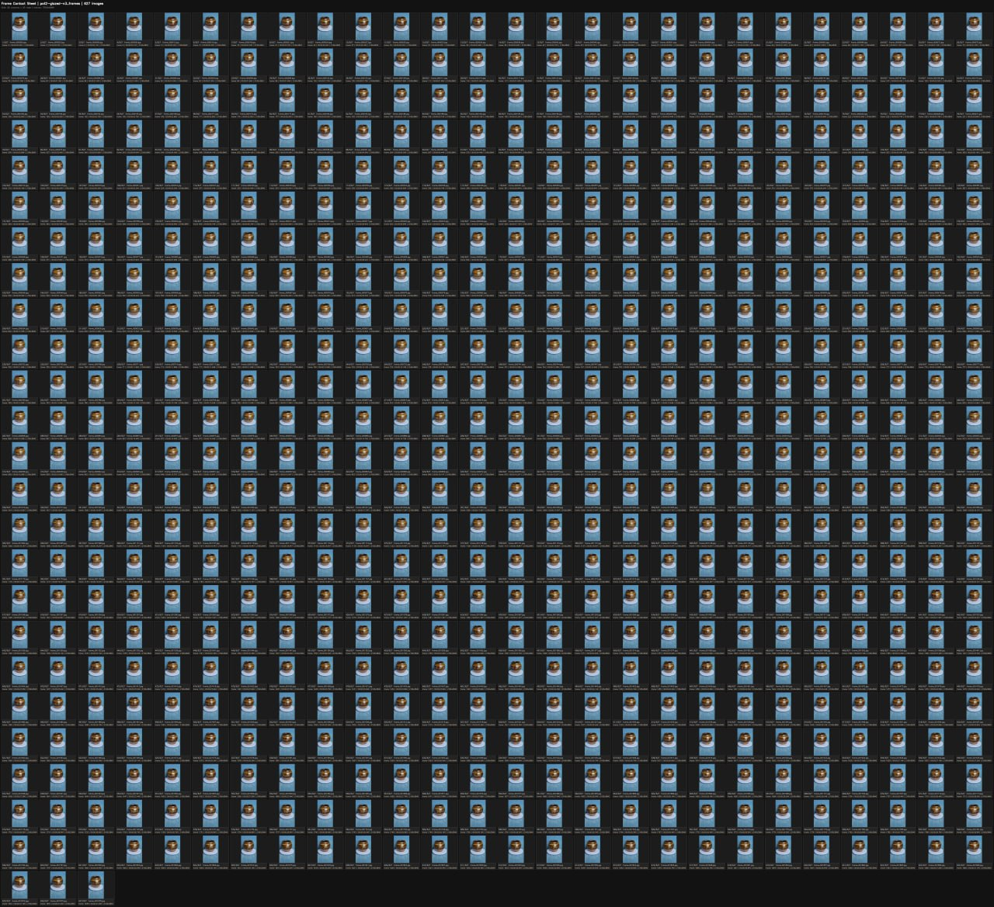
Fig. 5. Extracted frames from video recordings of the 1st pot.
An important part of this week's work was determining how frequently frames should be selected from the videos. The team used trial and error instead of choosing a sampling interval in advance. Several versions of the dataset were generated and visually compared, including sequences containing every frame, every second frame, every third frame, every fifth frame, and wider intervals. Selecting every frame created a large number of nearly identical images with very little movement between consecutive views. Every second frame reduced some redundancy but still produced relatively small changes in viewpoint. Wider intervals such as every fifth frame produced more visible movement but also increased the difference between neighboring views.
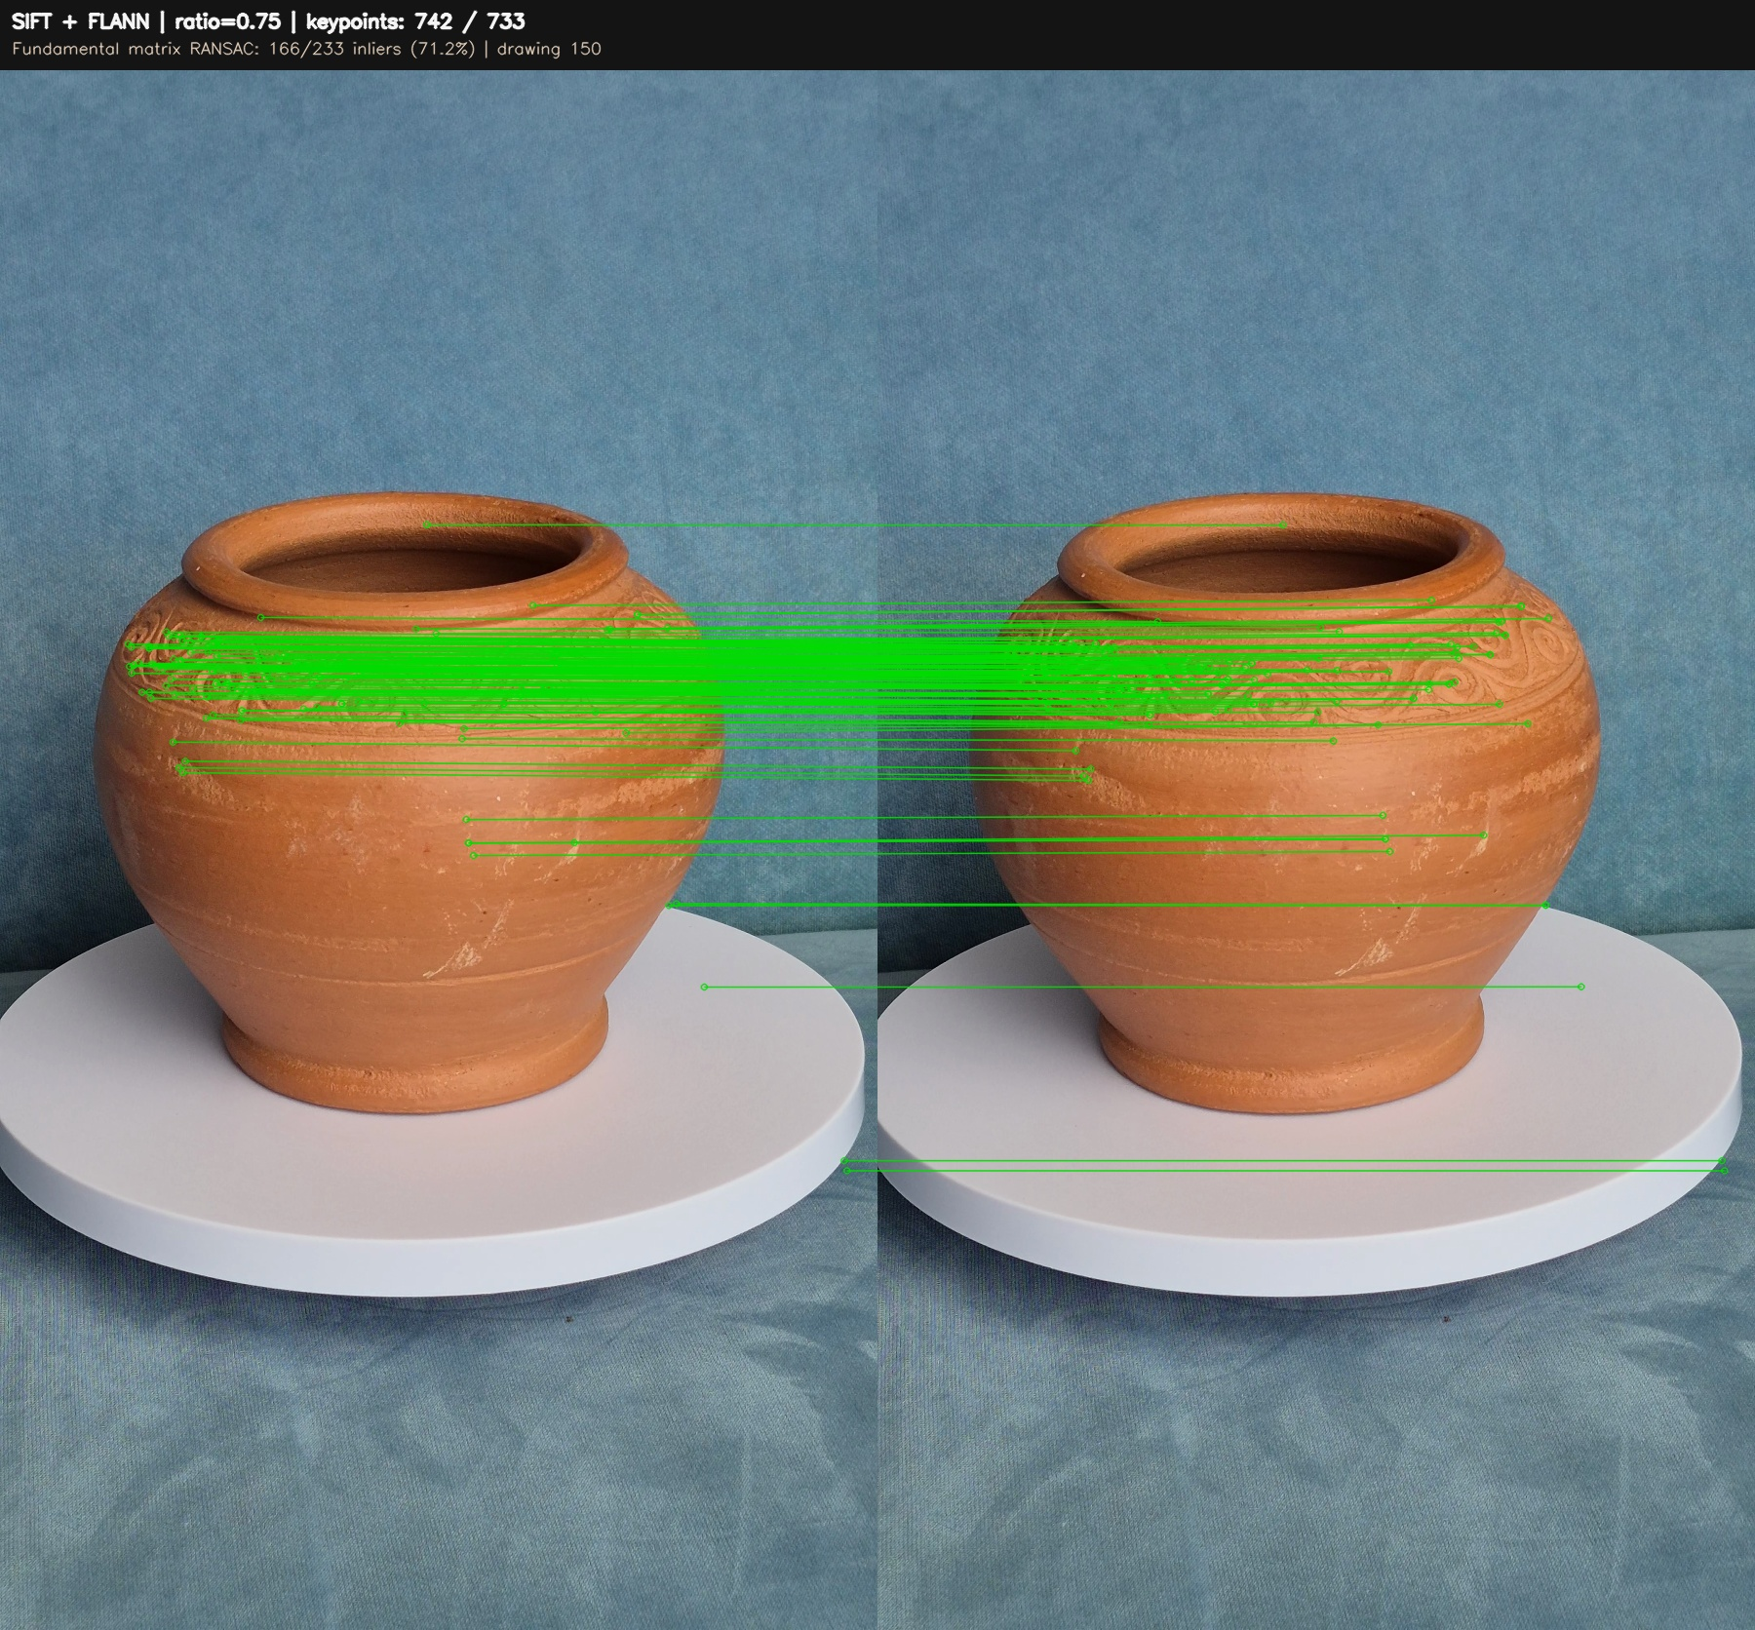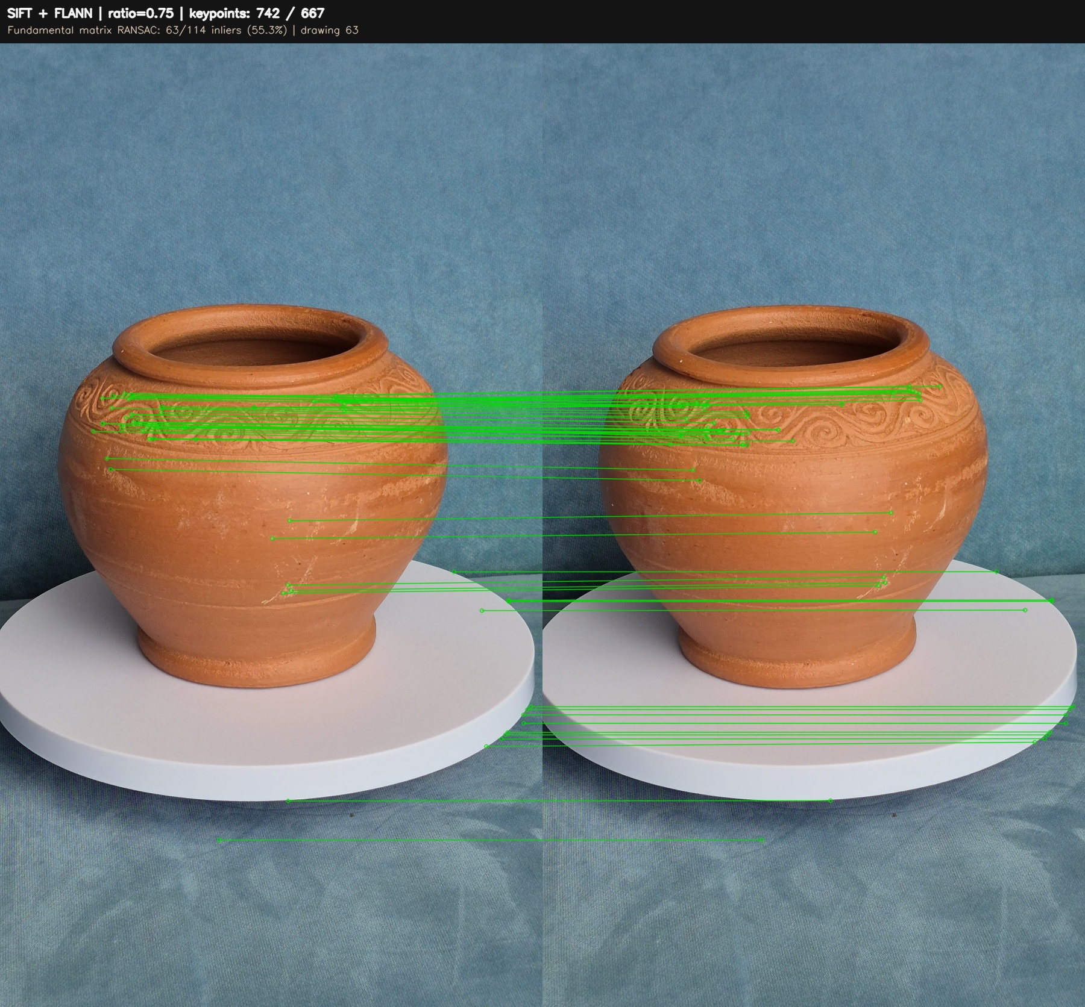
Fig. 6a. Fig. 6b.
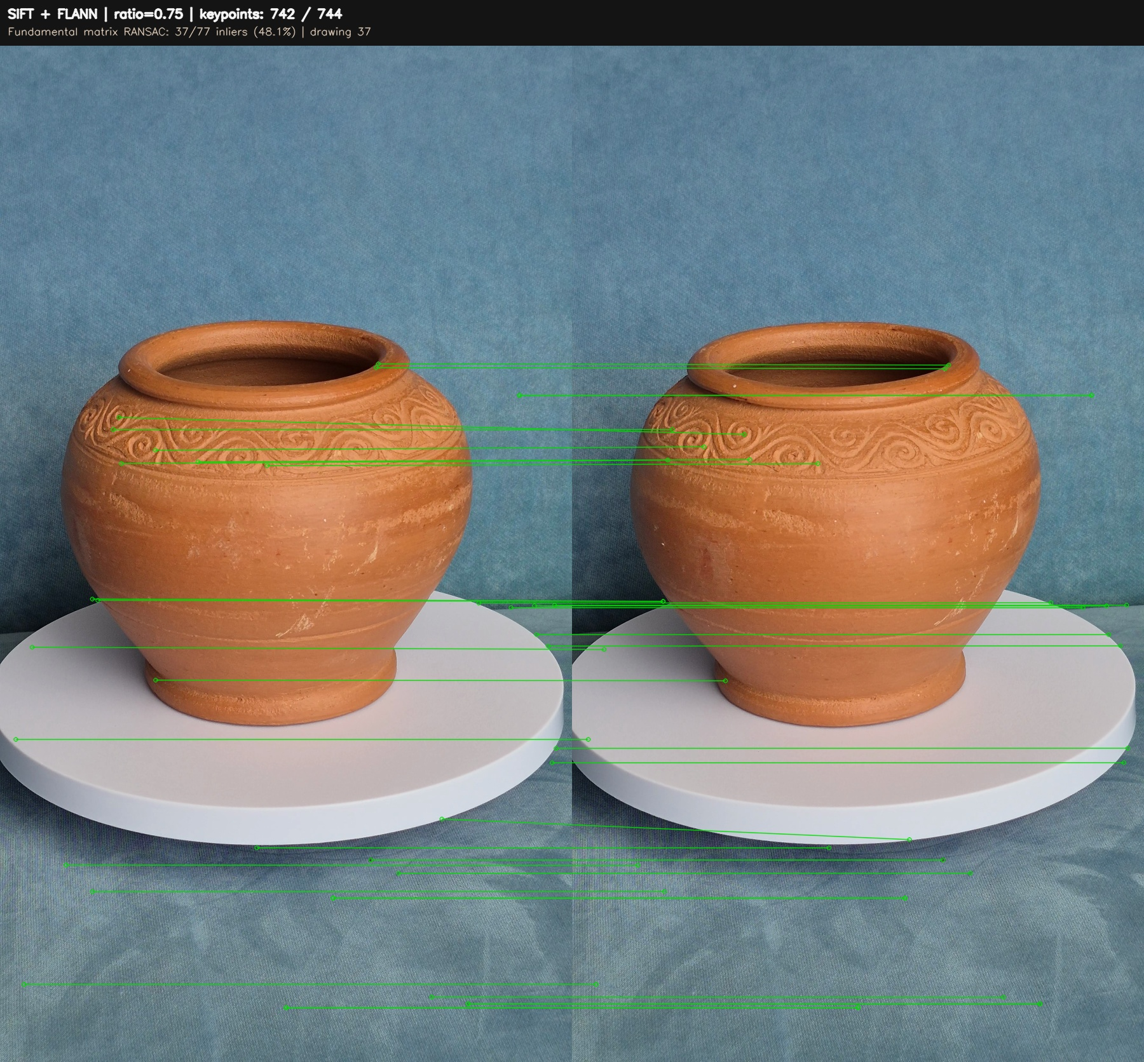
Fig. 6c.
Fig. 6a. SIFT feature matching between two images 30 frames apart. FLANN matching and RANSAC retained 166 RANSAC inliers from 233 Lowe-filtered matches.
Fig. 6b. SIFT feature matching between 2 images 75 frames apart. FLANN matching and RANSAC retained 63 RANSAC inliers from 114 Lowe-filtered matches.
Fig. 6c. SIFT feature matching between 2 images 120 frames apart. FLANN matching and RANSAC retained 37 RANSAC inliers from 77 Lowe-filtered matches.
A preliminary feature-matching test was conducted using SIFT, FLANN matching, Lowe's ratio test, and RANSAC. Using frame 879 as the reference, a 30-frame gap produced 233 matches with 166 RANSAC inliers and a 71.2% inlier rate. A 75-frame gap produced 114 matches with 63 inliers and a 55.3% inlier rate, while a 120-frame gap produced 77 matches with 37 inliers and a 48.1% inlier rate.
The number of detected SIFT keypoints remained relatively stable across the tested frames. This suggests that the decrease in matching performance was mainly caused by larger viewpoint changes rather than a lack of detectable features. Many reliable matches were found around the carved decorative band, while smoother regions produced fewer correspondences.
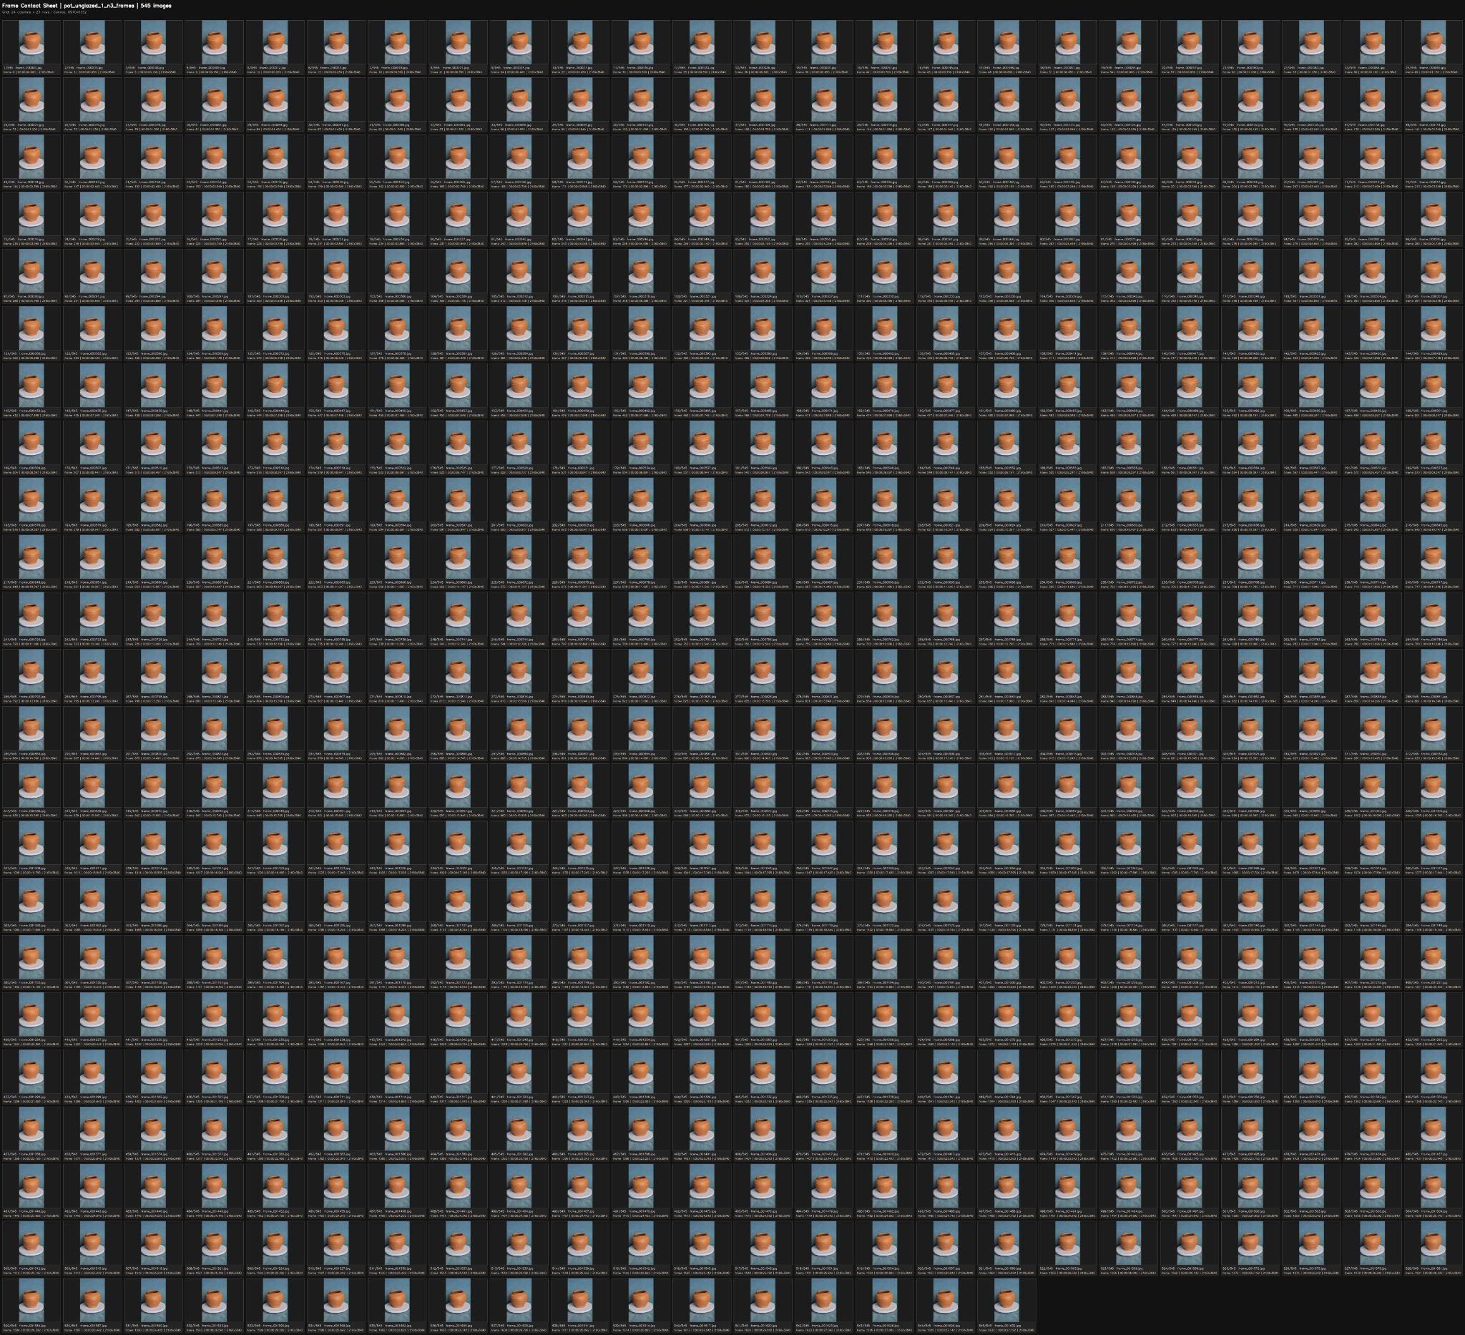
Fig. 7. Extracted frames from video recordings of the 2nd pot.
Background removal is the main preprocessing task still under development. The team is currently developing and testing an algorithm that can separate the pottery objects from the blue background in the extracted frames. The goal is to produce a cleaner and more consistent image sequence before the images are passed into the reconstruction pipeline. Because this stage is not yet complete, the current progress focuses on object capture, frame extraction, frame interval testing, and preparation of the source datasets rather than full 3D reconstruction.
We are also trying out different lighting options to find the setup that produces no shadow, no glare, enhances features for better detection, and works well with our background removal software.
The immediate next milestone is to complete and evaluate the background removal method and prepare the selected every-third-frame sequences for COLMAP. Initial reconstruction results will then be used to evaluate feature matching, image registration, camera pose estimation, and reconstruction completeness. The team will also continue evaluating whether the broken base can be repaired securely enough for a later capture session. If the repair is successful, an additional recording can be made so that the missing decorative component can be included in a later reconstruction attempt.

References
[1] R. Szeliski, Computer Vision: Algorithms and Applications, 2nd ed. Cham, Switzerland: Springer, 2022. [Online]. Available: https://szeliski.org/Book/
[2] J. L. Schönberger and J.-M. Frahm, "Structure-from-Motion Revisited," in Proc. IEEE Conf. Comput. Vis. Pattern Recognit. (CVPR), 2016, pp. 4104-4113, doi: 10.1109/CVPR.2016.445.
[3] J. L. Schönberger, E. Zheng, M. Pollefeys, and J.-M. Frahm, "Pixelwise View Selection for Unstructured Multi-View Stereo," in Computer Vision - ECCV 2016, pp. 501-518, doi: 10.1007/978-3-319-46487-9_31.
[4] AliceVision, "Meshroom: A 3D Reconstruction Software." [Online]. Available: https://alicevision.org/view/meshroom.html. Accessed: Aug. 16, 2026.
[5] V. Benniman, "Exploring Thai Ceramics (Part 1): What is Thai Ceramics?" Thailand Foundation, Feb. 23, 2026. [Online]. Available: https://thailandfoundation.or.th/exploring-thai-ceramics-part-1-what-is-thai-ceramics/. Accessed: Aug. 16, 2026.
[6] Sirindhorn Anthropology Centre, "Museum of Pottery Made in Thailand," Sep. 4, 2017. [Online]. Available: https://www.sac.or.th/portal/th/exhibition/detail/29. Accessed: Aug. 16, 20
[7] Fine Arts Department, Ministry of Culture, Thailand, "The Origin of Ratchaburi Dragon Jars" (in Thai). [Online]. Available: https://www.finearts.go.th/promotion/view/36293-. Accessed: Aug. 16, 2026.
[8] Sirindhorn Anthropology Centre, "Ratchaburi Dragon Jar," Traditional Objects of Everyday Use (in Thai). [Online]. Available: https://traditional-objects.sac.or.th/th/equipment-detail.php?ob_id=245. Accessed: Aug. 16, 2026.

